**AI Planning and Autonomy Summary**

­­**Classical Planning Model**:

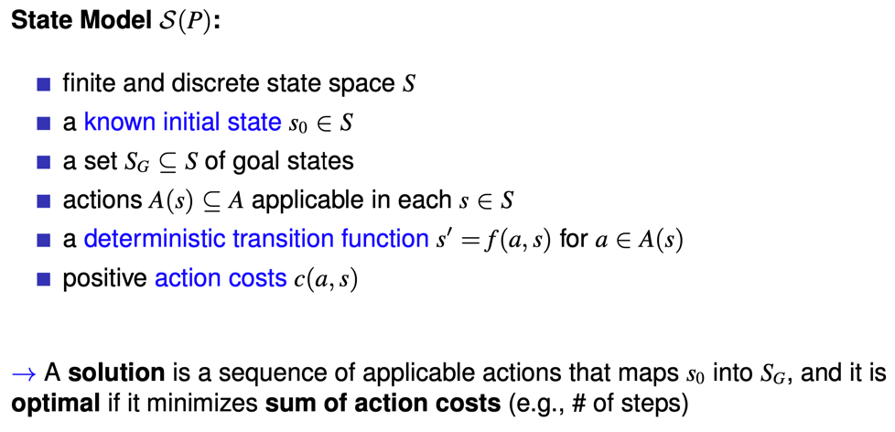

**Blind Search vs Heuristic Search**:

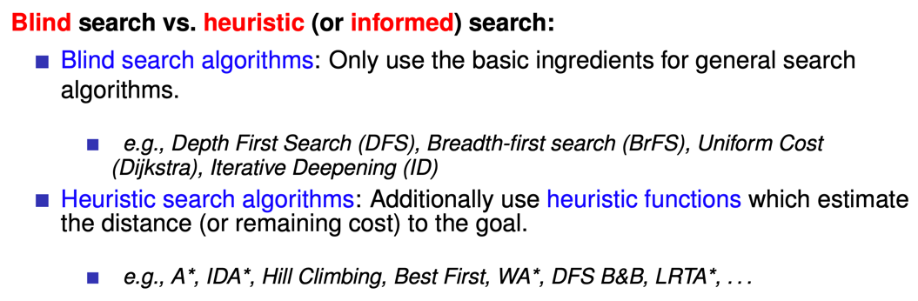

**Systematic Search vs Local Search**:

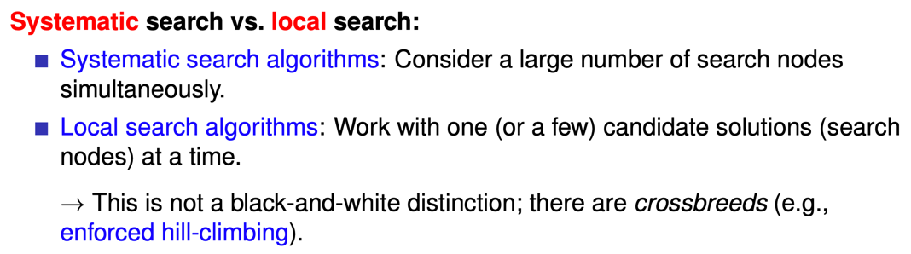

**Evaluation Criteria**:

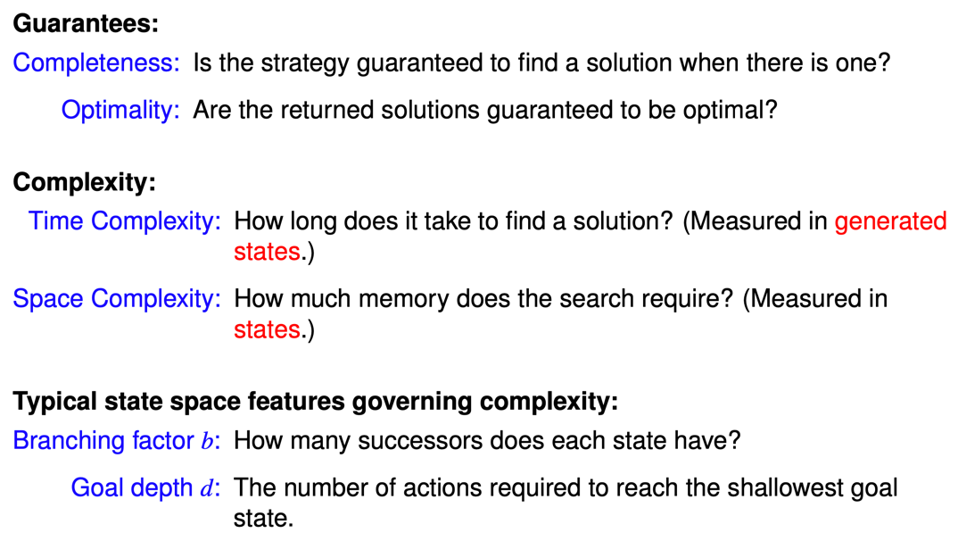

**BFS**:

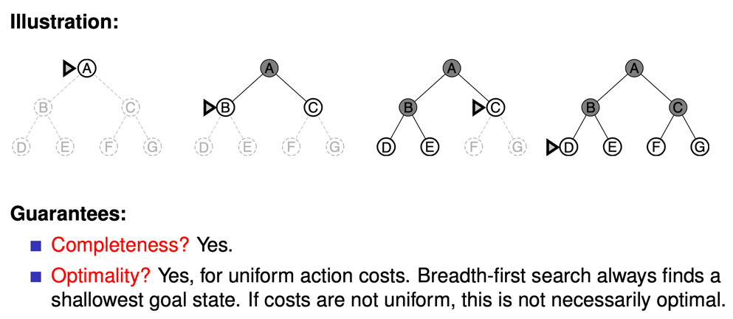

**DFS**:

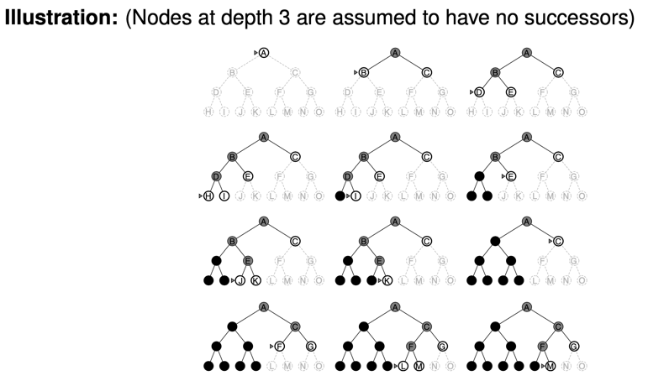

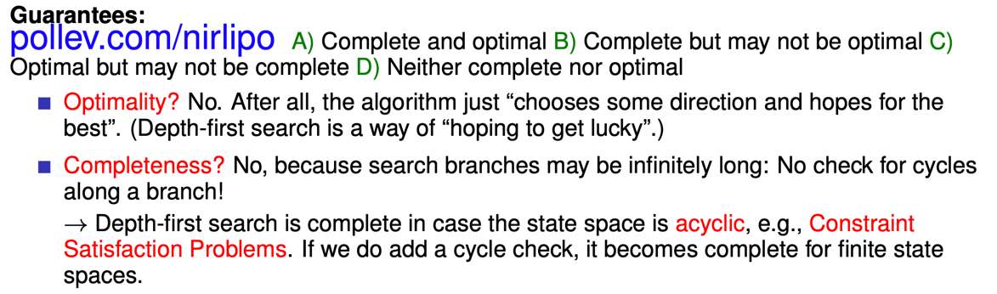

**Iterative Deepening**:

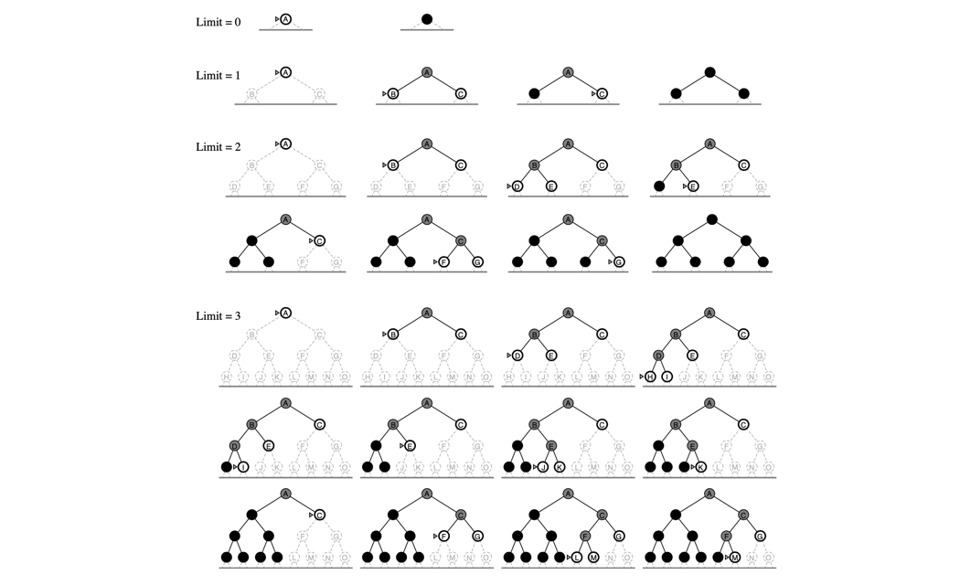



**Heuristic Search**:

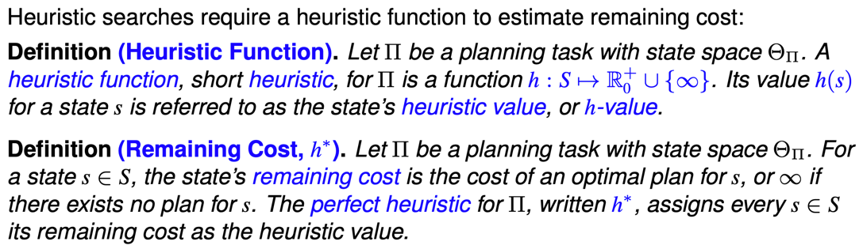

**Properties of Heuristic Functions**:

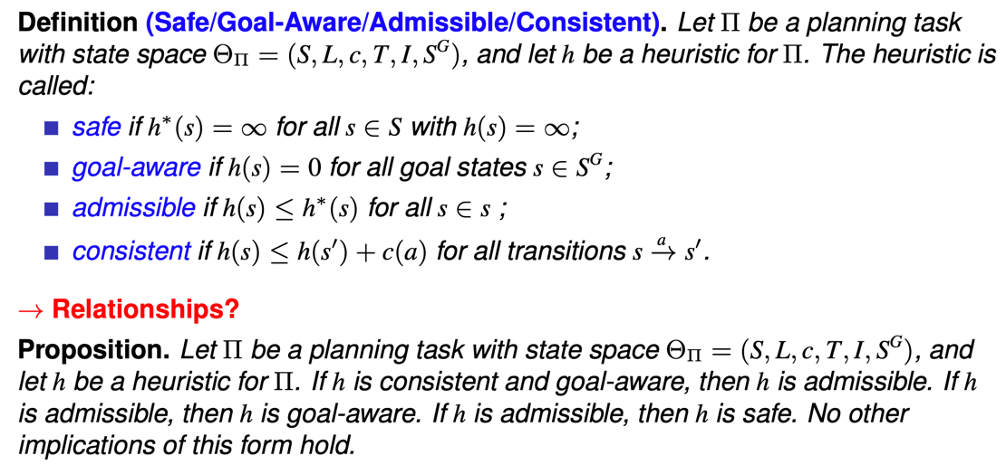

**Greedy Best-First Search**:

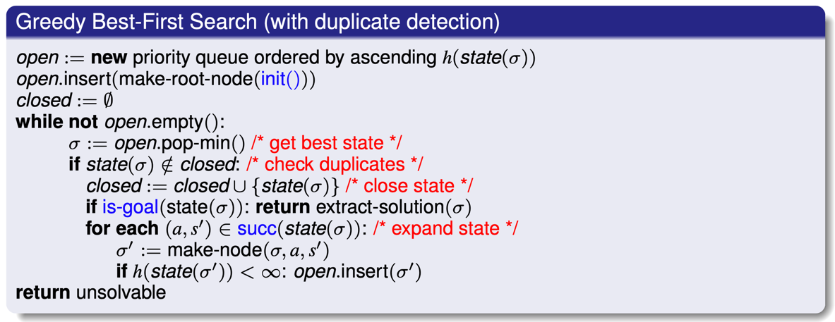

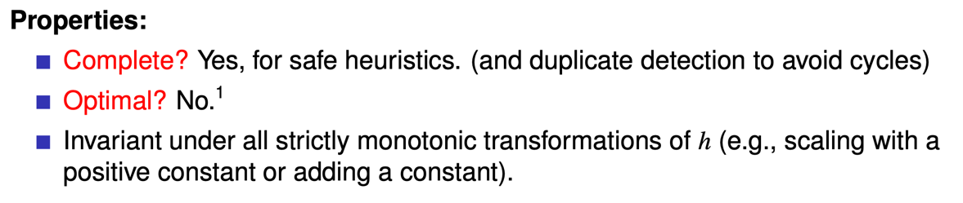

**A\***:

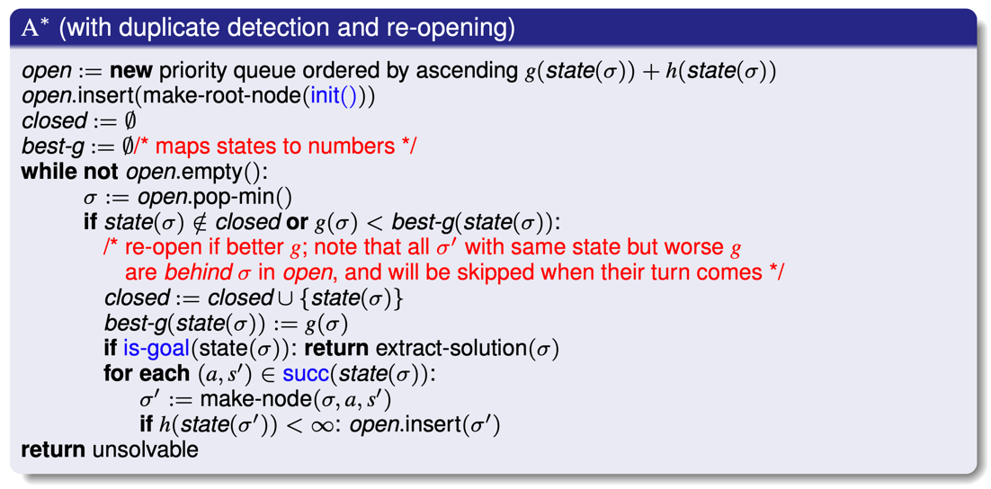

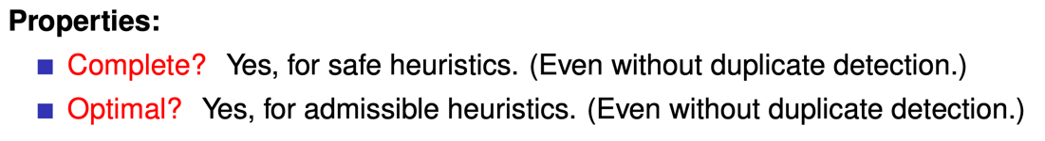

**Weighted A\***:

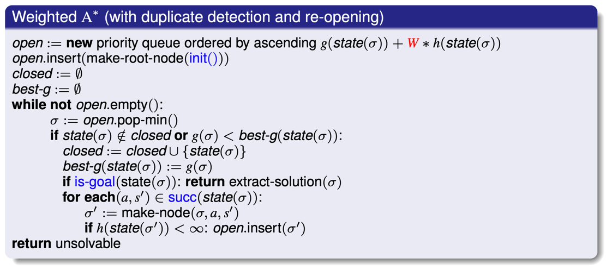

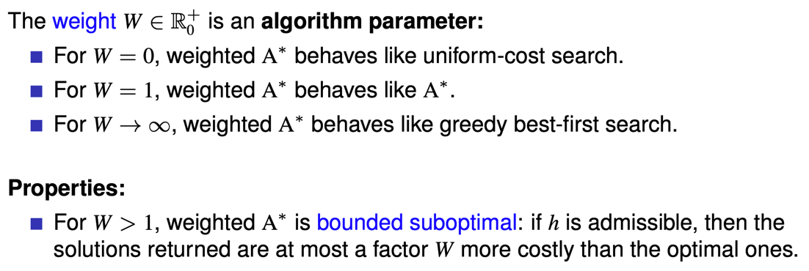

**Hill Climbing**:

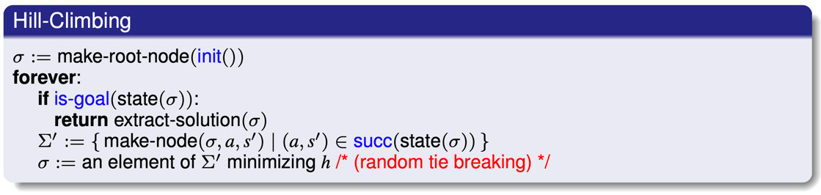

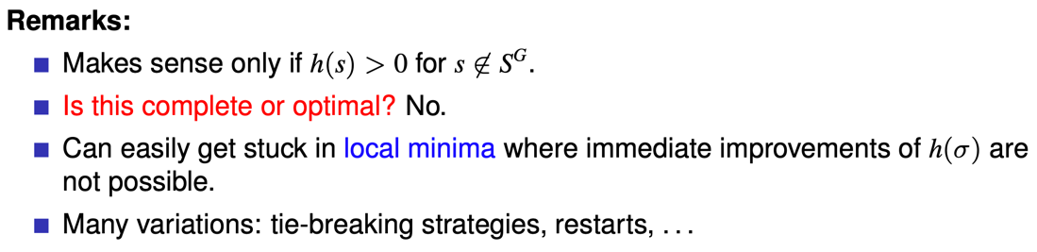

**Enforced Hill Climbing**:

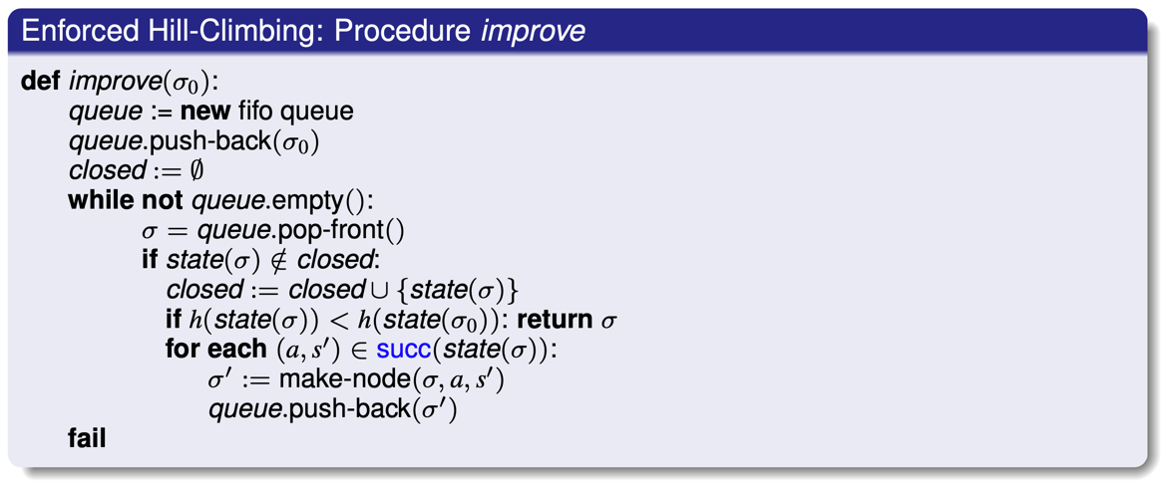

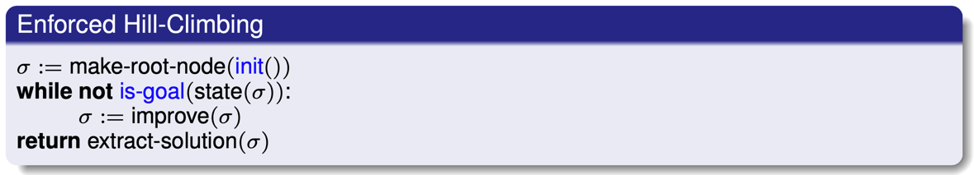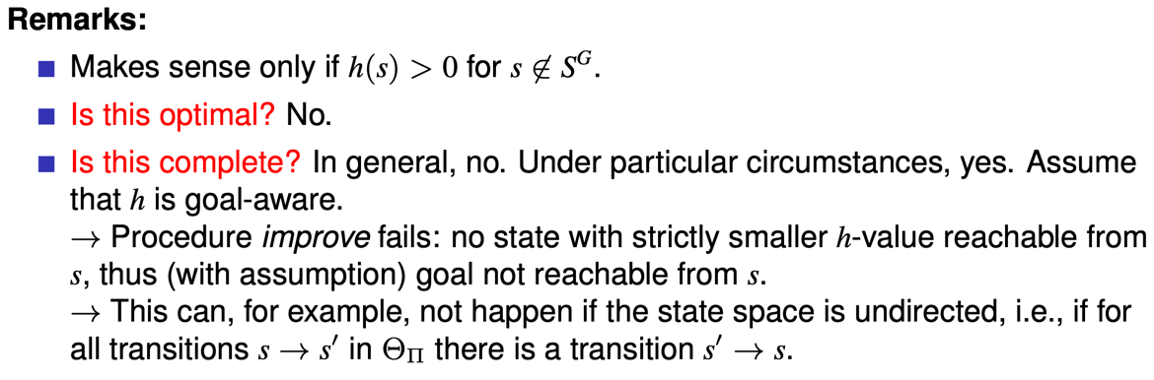

**Overview of Search Algorithms**:

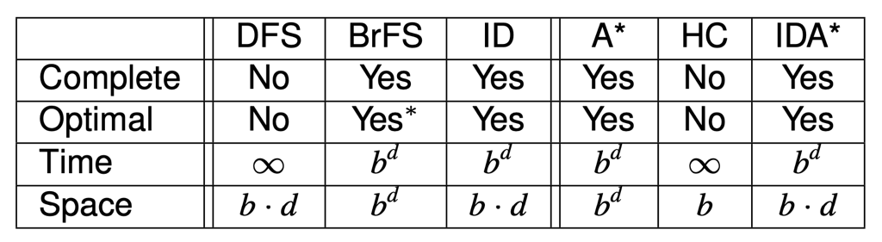

**Three Approaches to the Problem**:

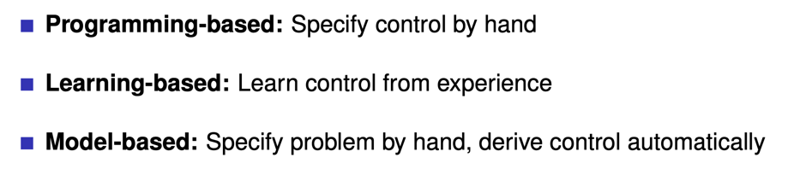

**Programming-Based Approach**:

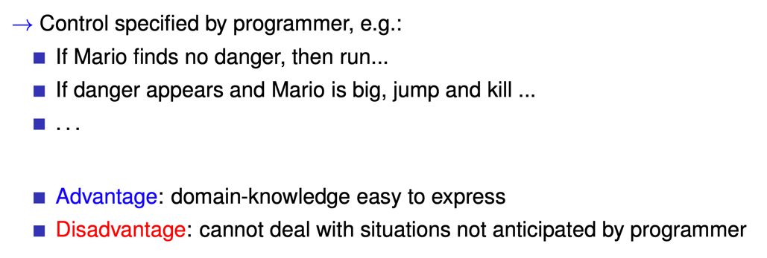

**Learning-Based Approach**:

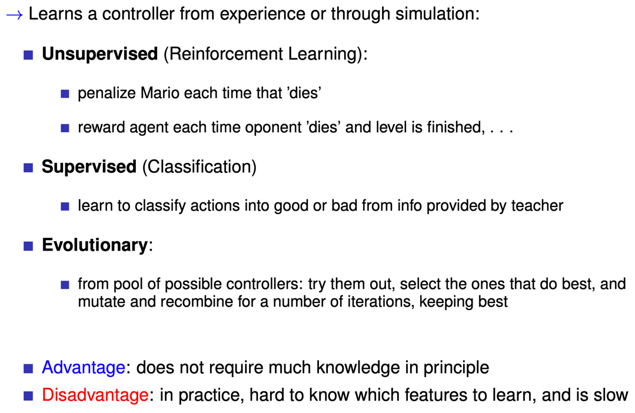

**STRIPS**:

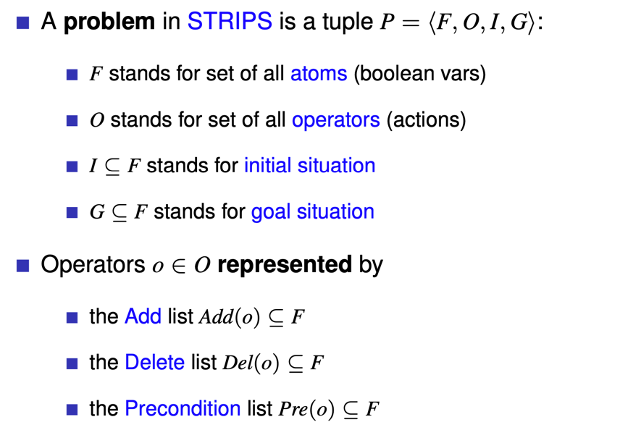

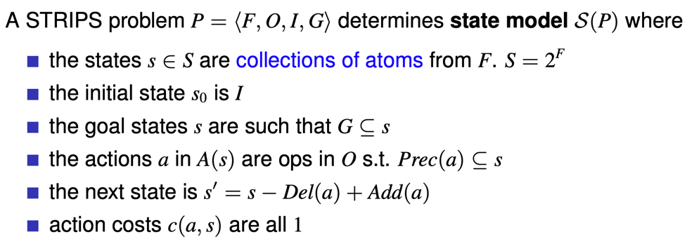

**PDDL**:

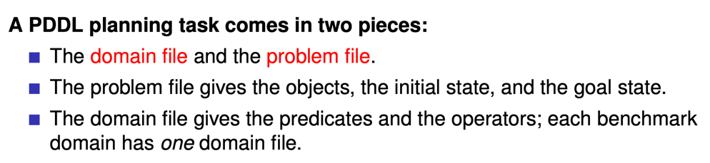

Satisfying planning is P and optimal planning NP-complete and both of them are PSPACE-complete in STRIPS.

**Relax A Problem Informally**:

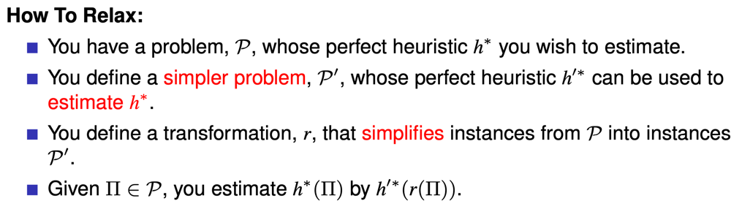

**Relax A Problem Formally**:

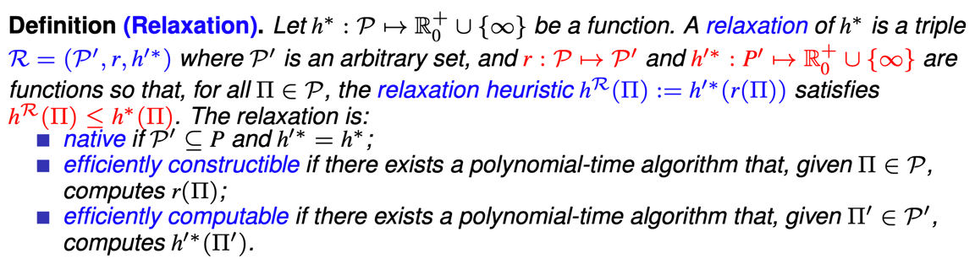

**Delete Relaxation**:

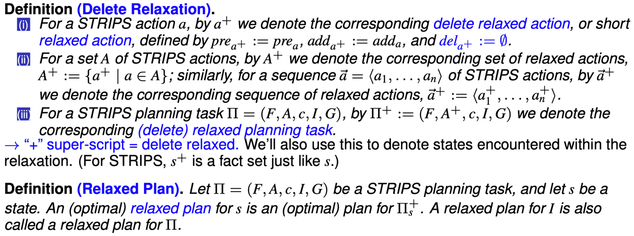

**State Dominance**:



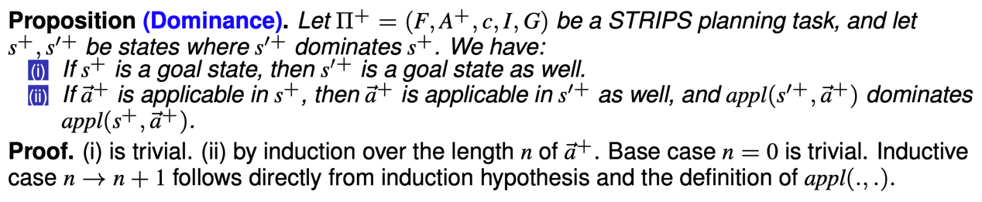



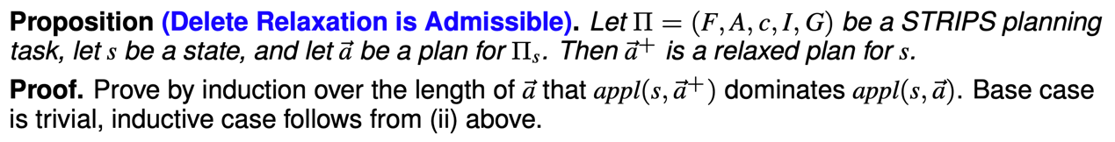

**Greedy Relaxed Planning**:

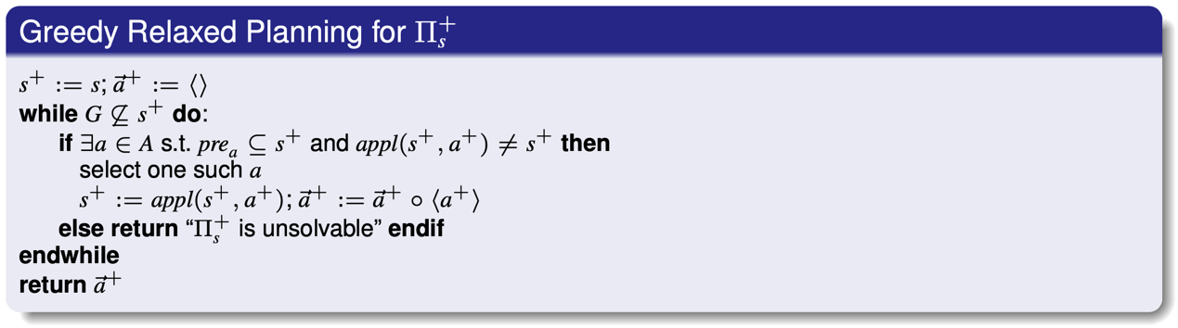

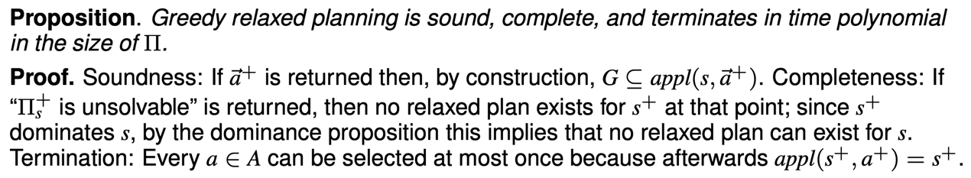

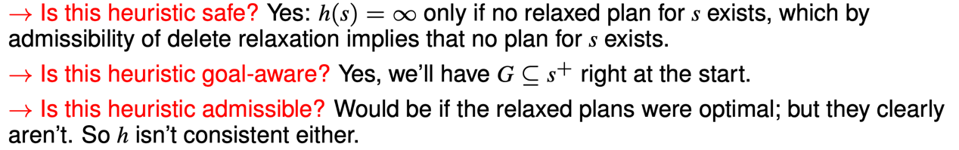

**Optimal Relaxed Planning Heuristic**:

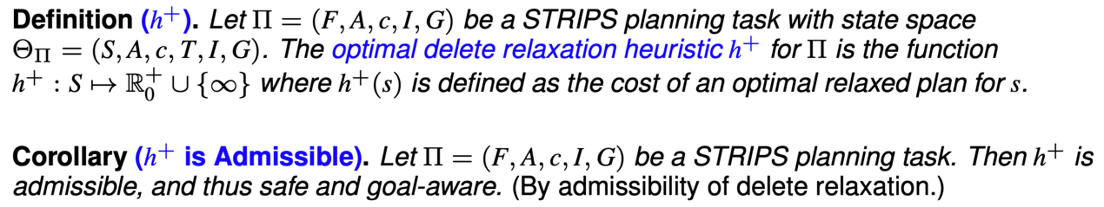

**Additive Heuristics**:

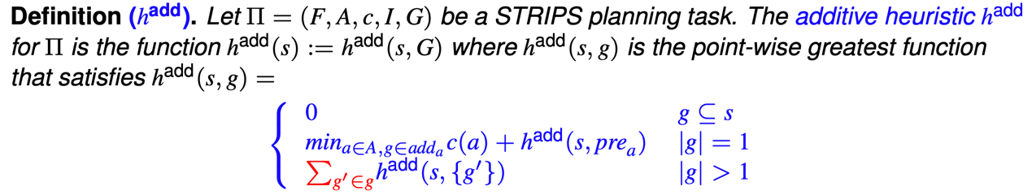

**Maximum Heuristics**:

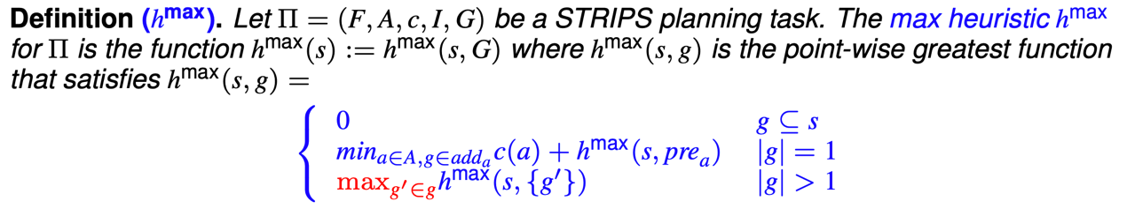

**Properties of Additive and Maximum Heuristics**:

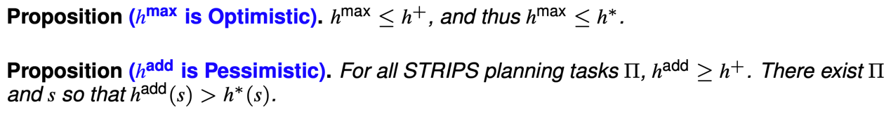



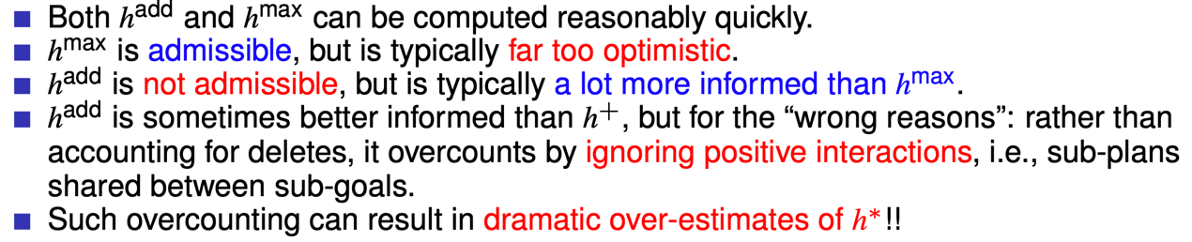

**Bellman-Ford for $h^{max}$ and $h^{add}$** :

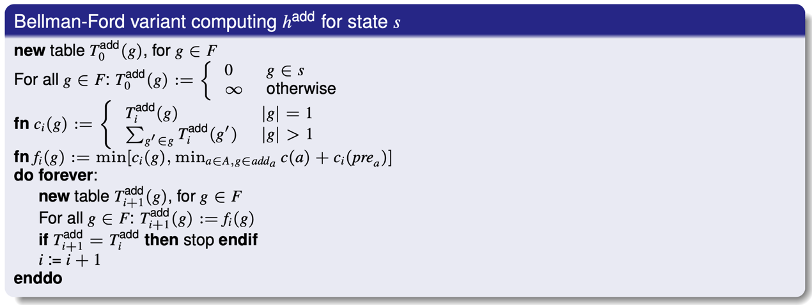

**Best-Supporter Function**:

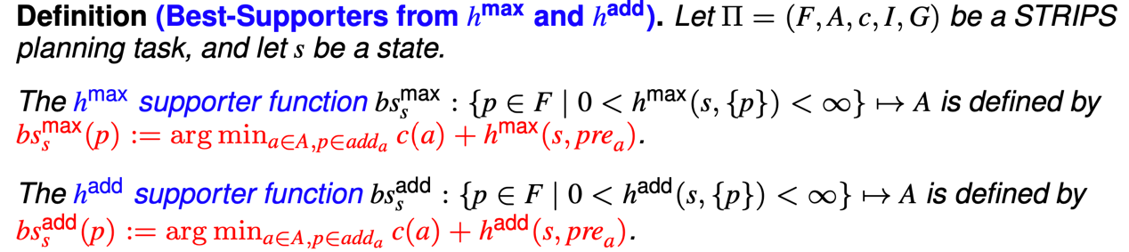

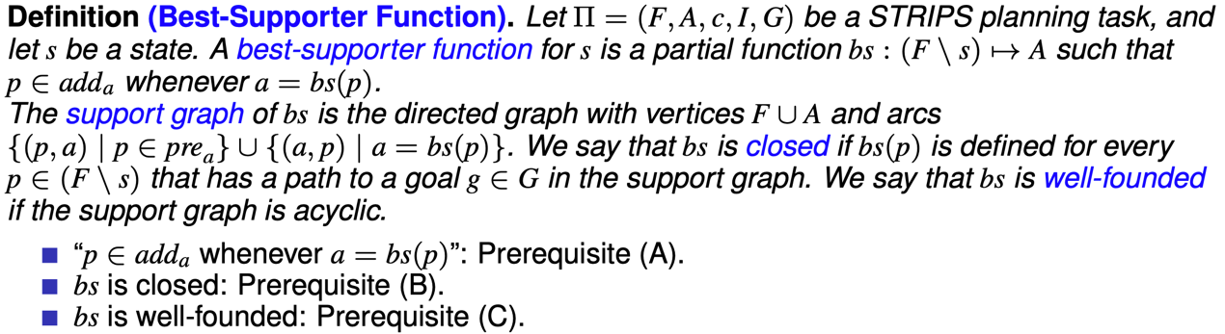

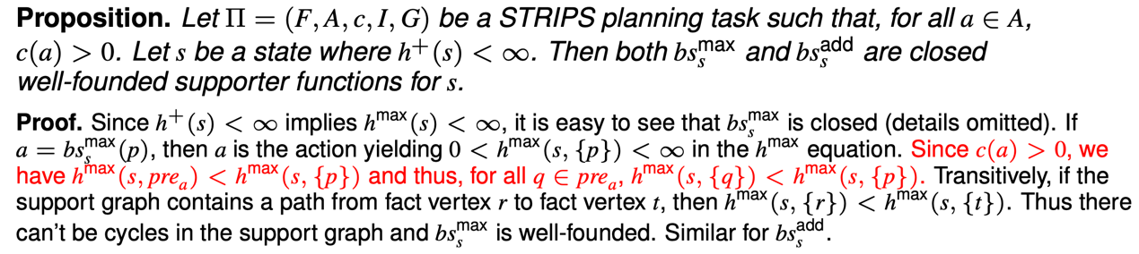

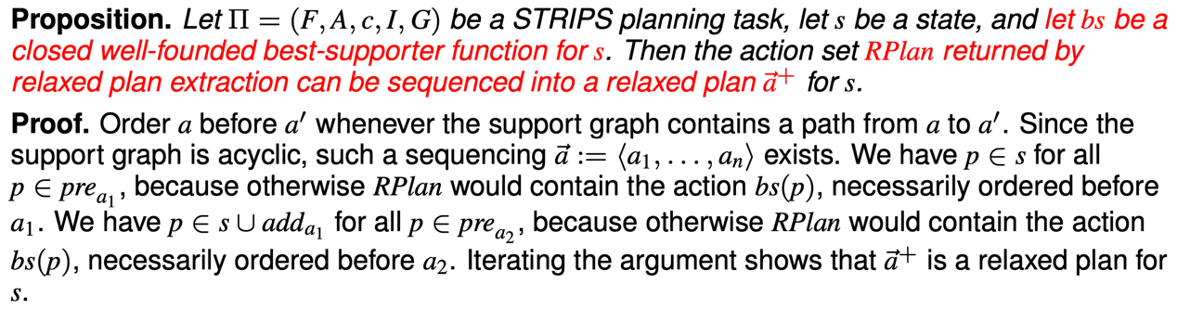

**Relaxed Plan Extraction**:

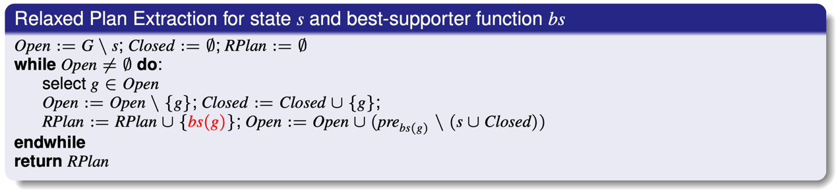

**Relaxed Plan Heuristic**:

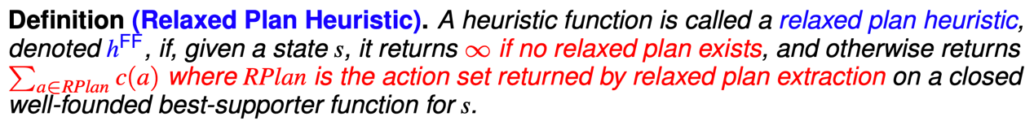



**Novelty**:

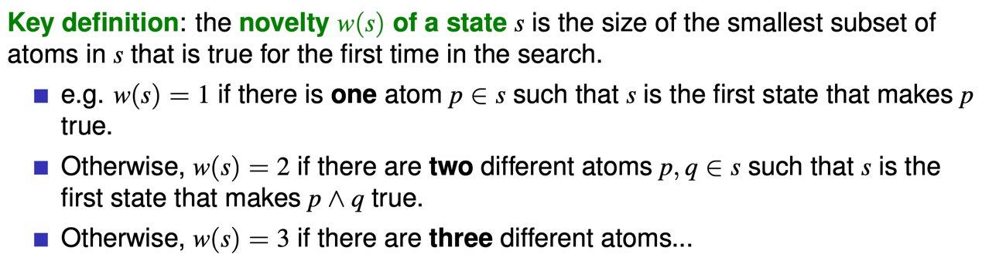

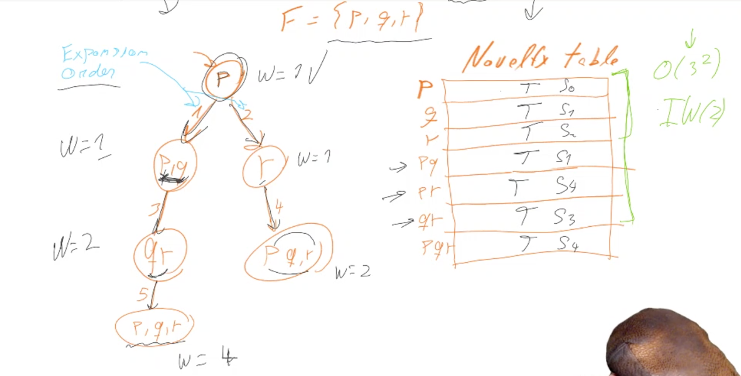

**Iterated Width**:

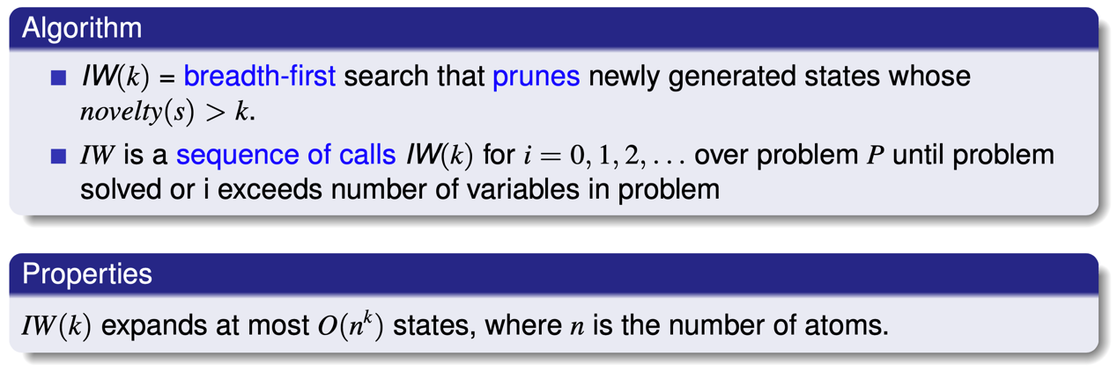

**Serialized Iterated Width**:

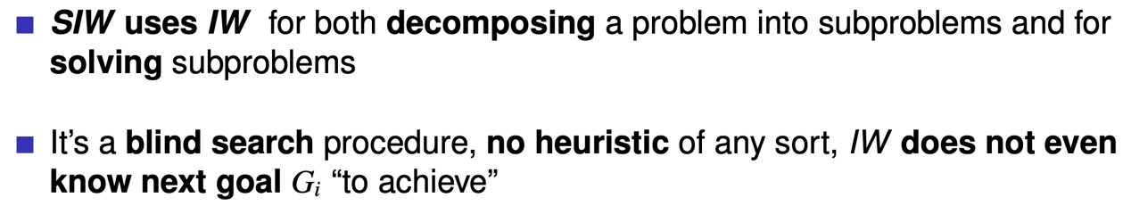

**Markov Decision Process**:

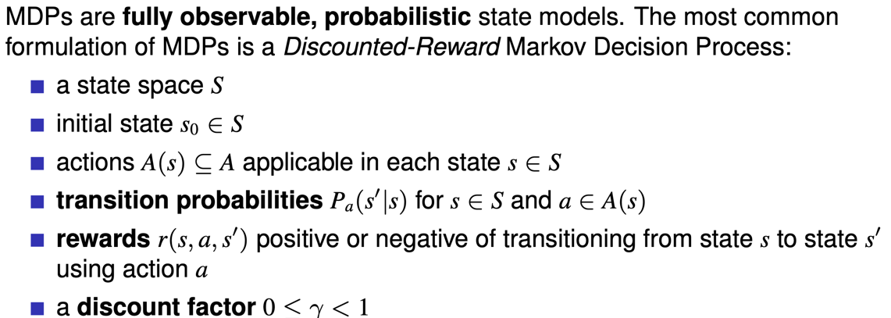

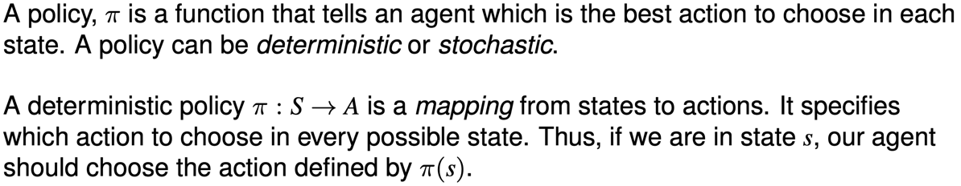

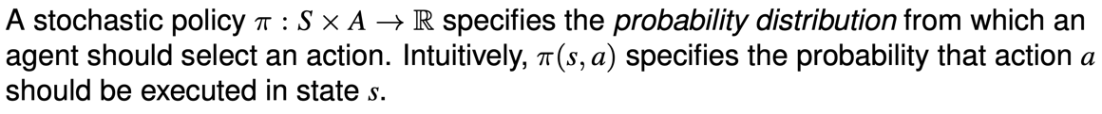

**Expected Value of Policy**:

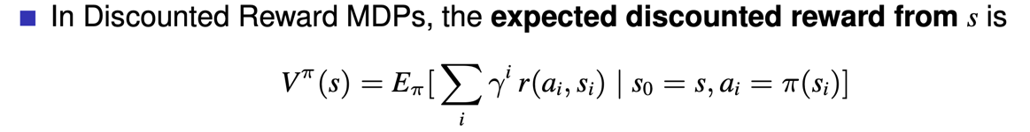

**Discounted Reward in Bellman Equation**:



**Q-Function**:



**Value Iteration**:

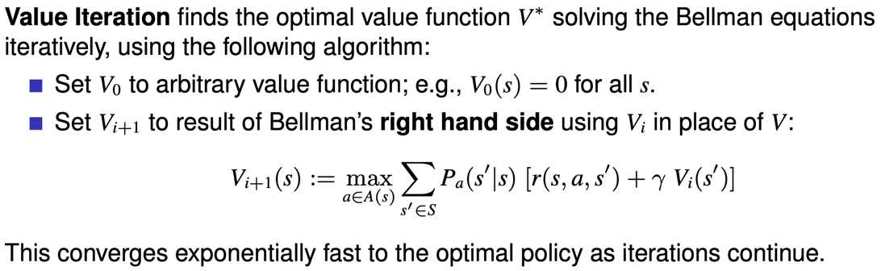

Complexity: $O({|S|}^{2}|A|)$

**Extract Policy in Value Iteration**:

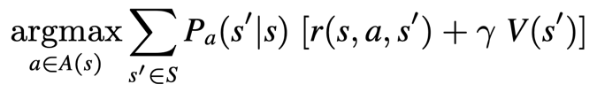 or 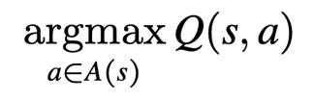

**Policy Iteration**:

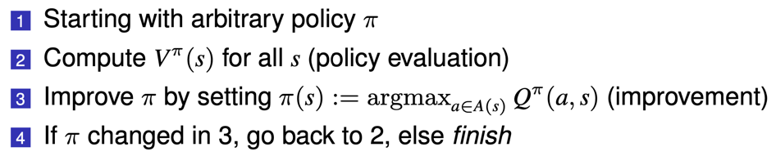

* Policy Evaluation:

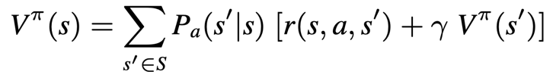

* Policy Iteration:

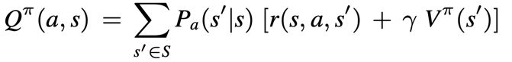

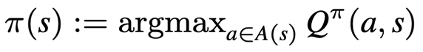

Complexity: $O({|S|}^{3}+{|S|}^{2}|A|)$

**Partially Observable MDP**:

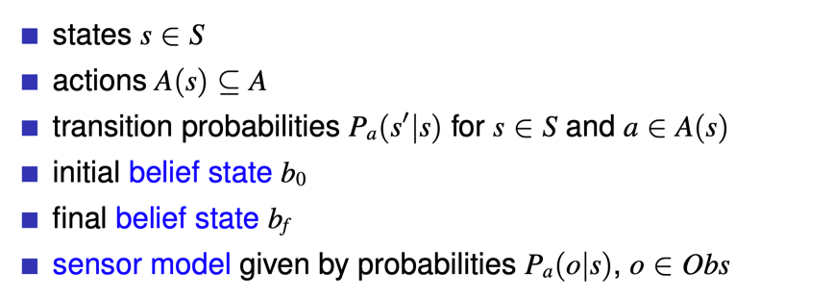

**Offline Planning vs Online Planning**:

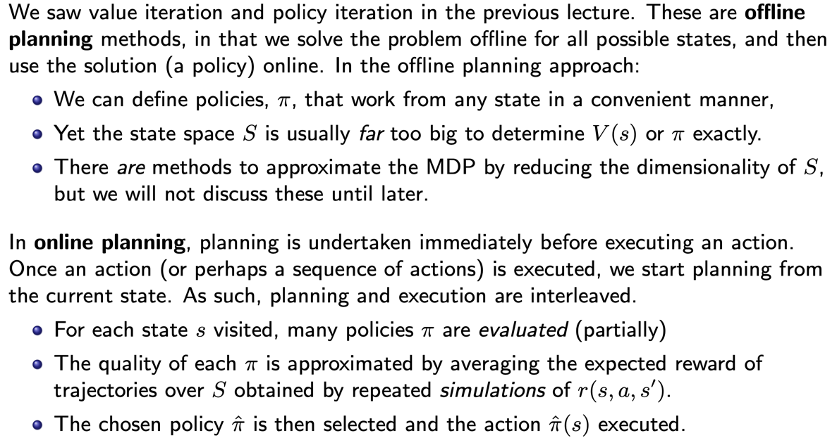

**Monte Carlo Tree Search**:

4 Steps: Selection, Expansion, Simulation, Backpropagation.

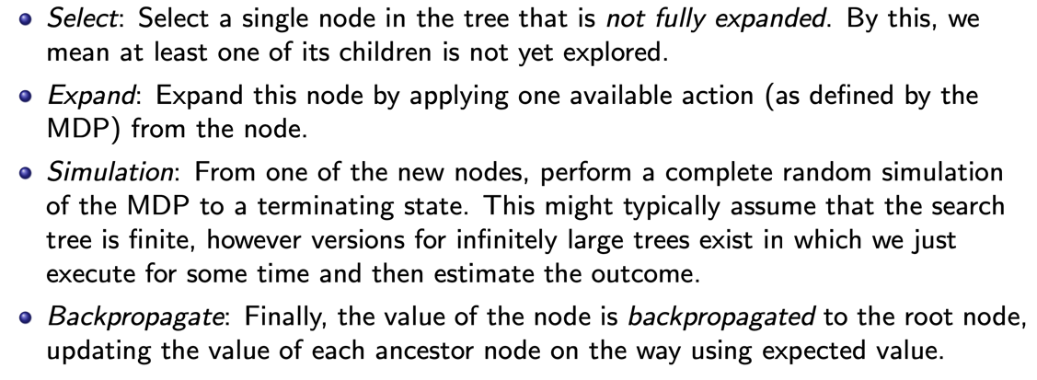

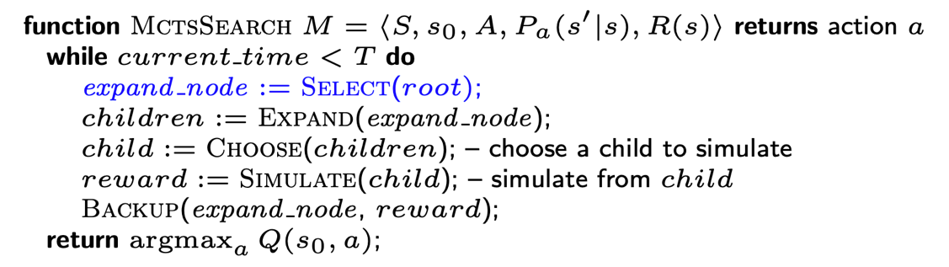

**Uniform Sampling**:

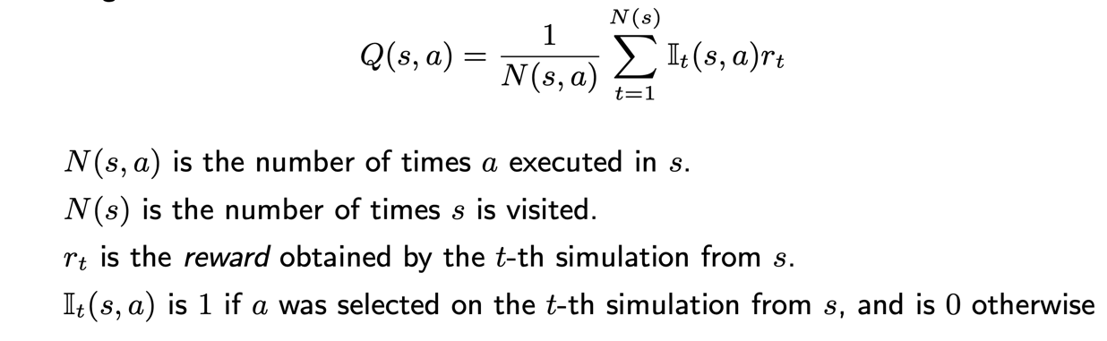

**Multi-Armed Bandit**:

* Definition

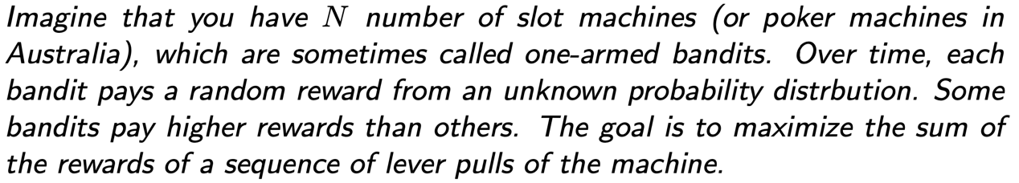

* Regret: the expected loss due to not choosing the best action.

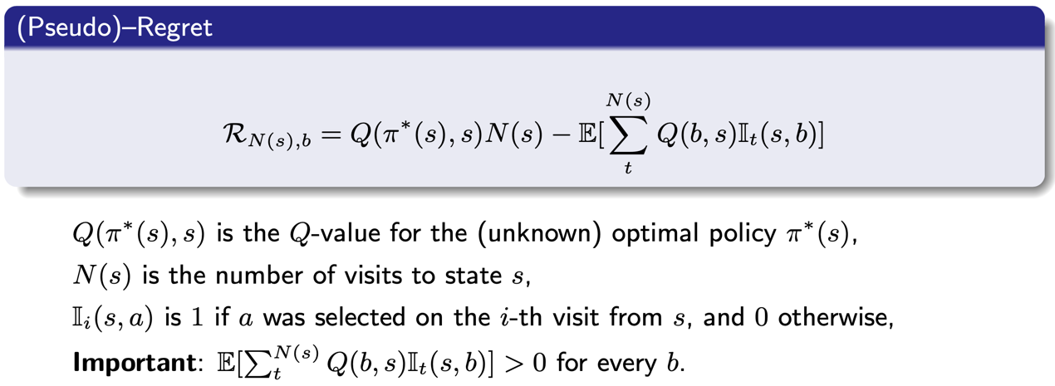

**Exploitation vs Exploration**:

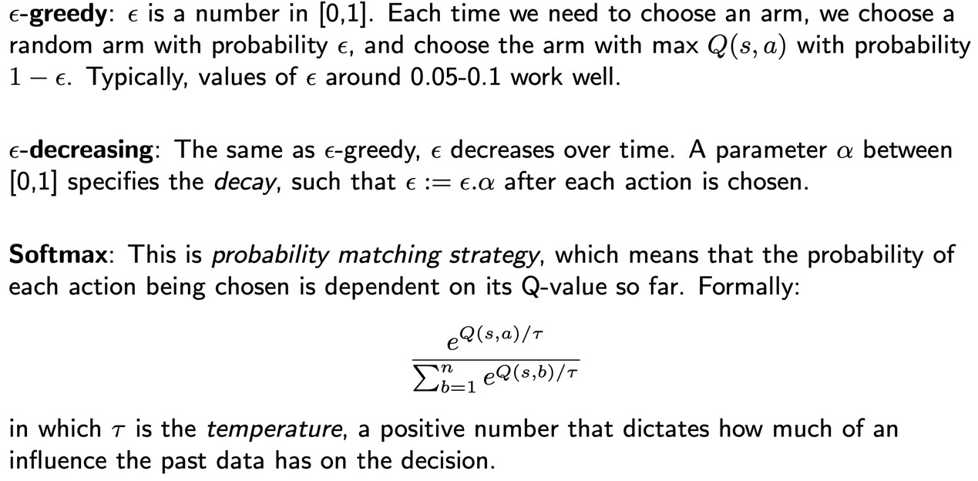

**Upper Confidence Bound**:

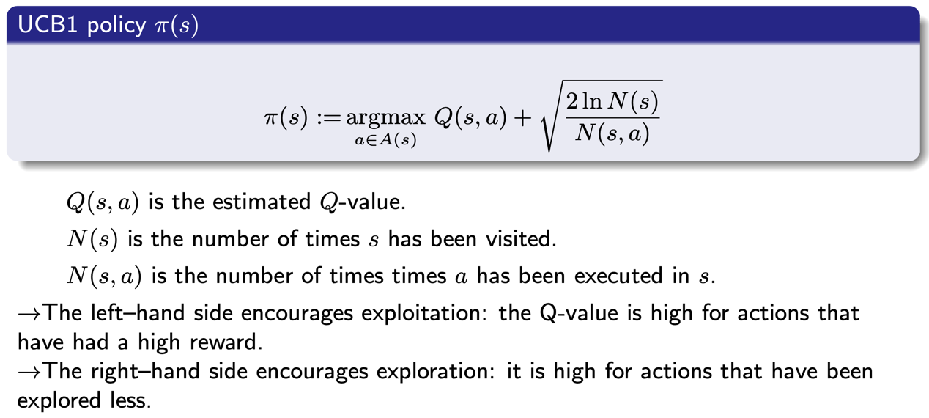

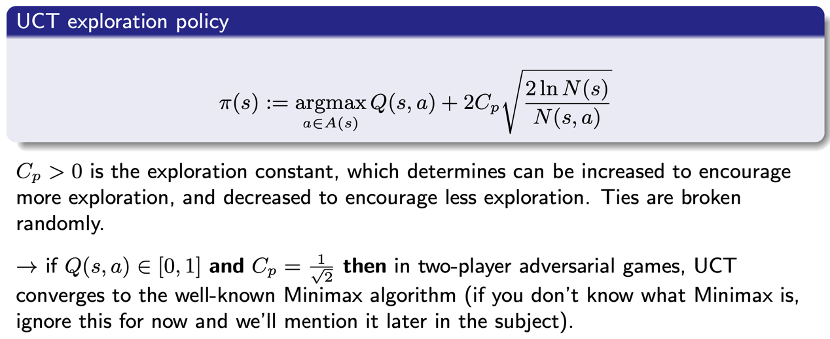

**Value/Policy Iteration vs MCTS**:

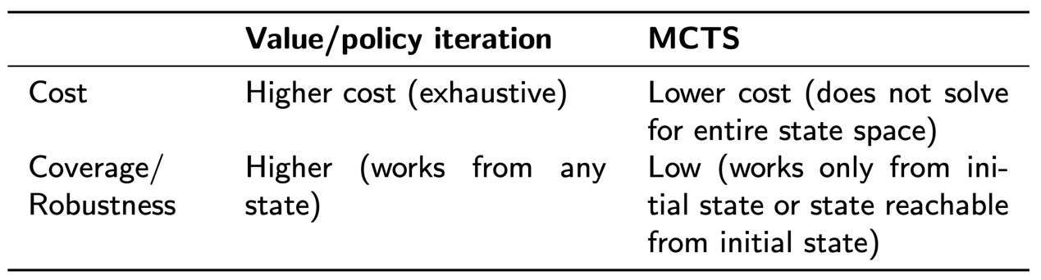

**Q-Learning**: offline learning.

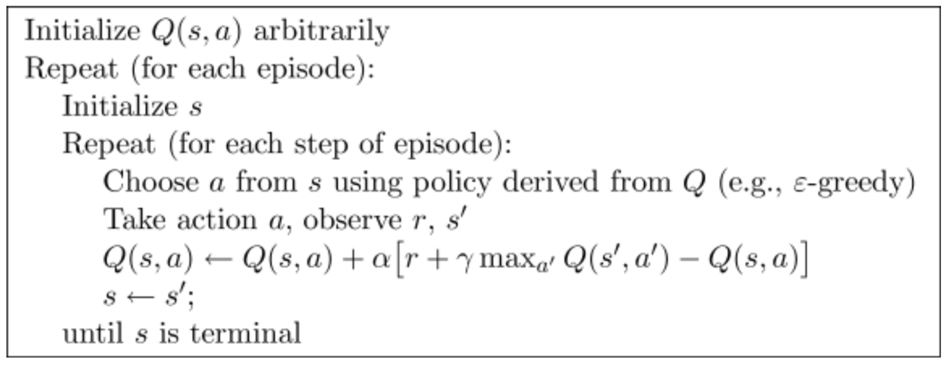

**SARSA**: online learning.

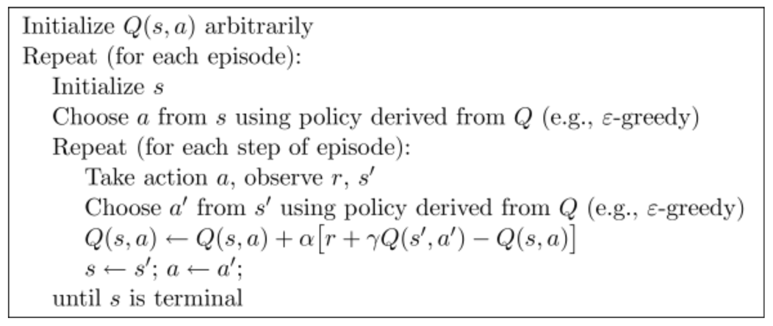

**Q-Learning vs SARSA**: Q-learning learns an optimal path, while SARSA learns a safe path.

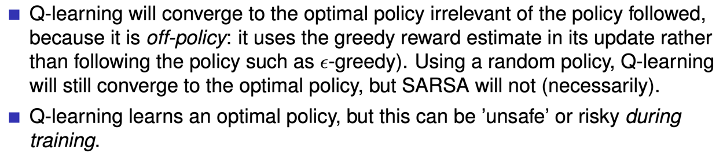

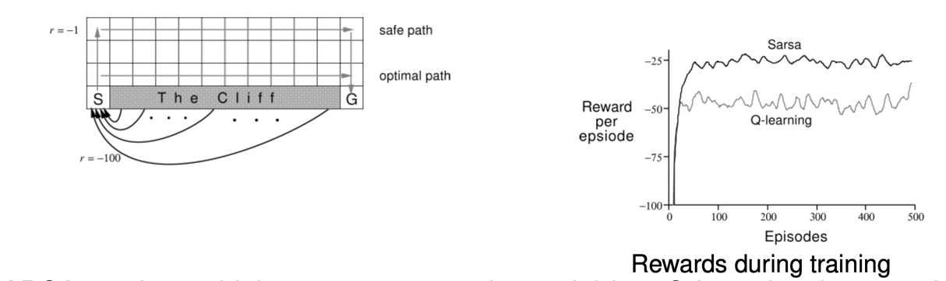

**Linear Function Approximation**:

* Overall process

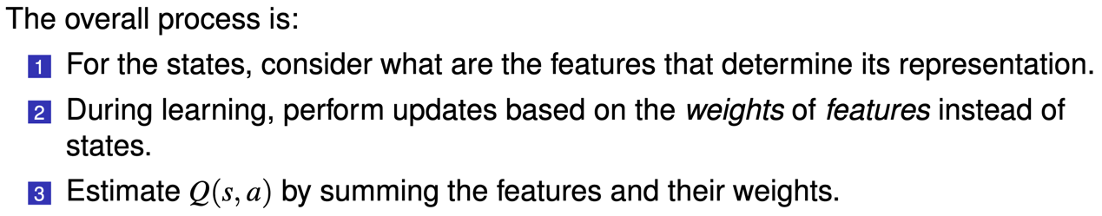

* Representation of two vectors

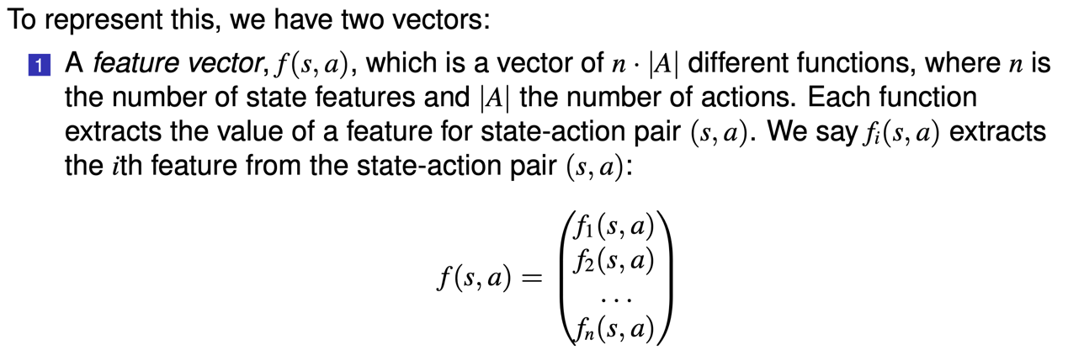

* state-action features:

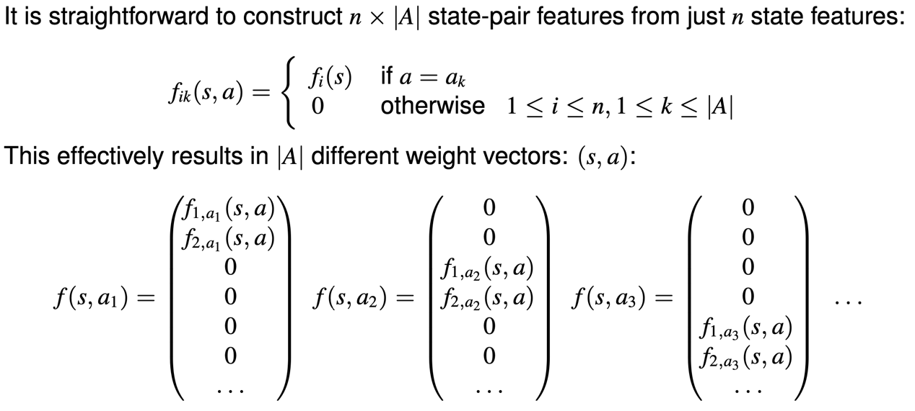

* Q-function computation:

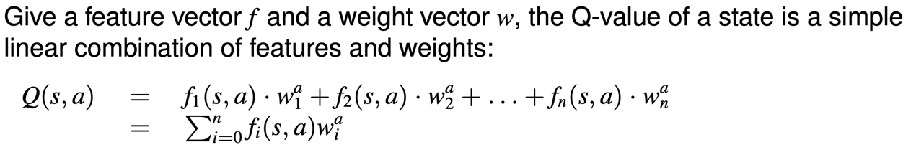

* Q-function parameter update (linear approximation):

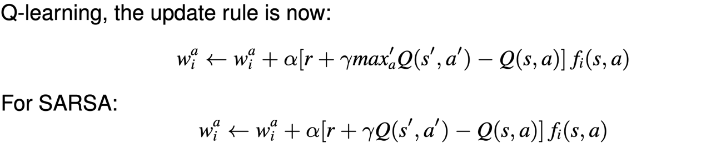

* Q-function parameter update (neural network):

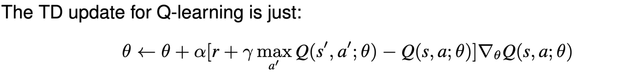

**Reward Shaping**:

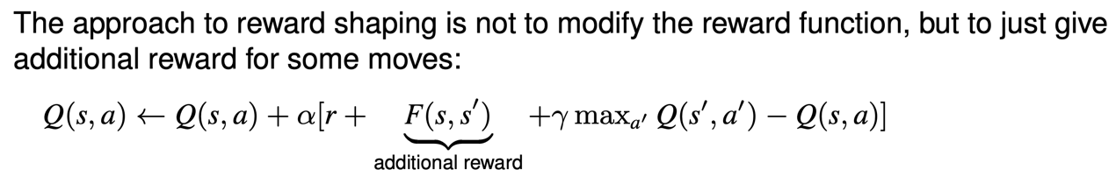

**Potential-based Reward Shaping**:

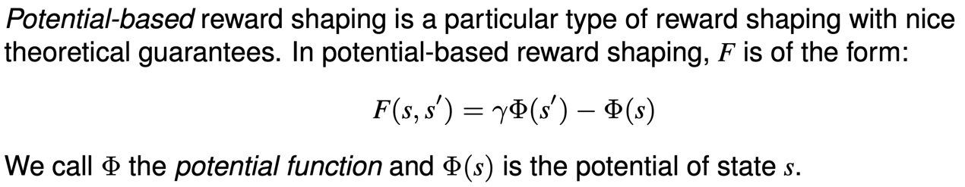

**Q-function Initialization**:

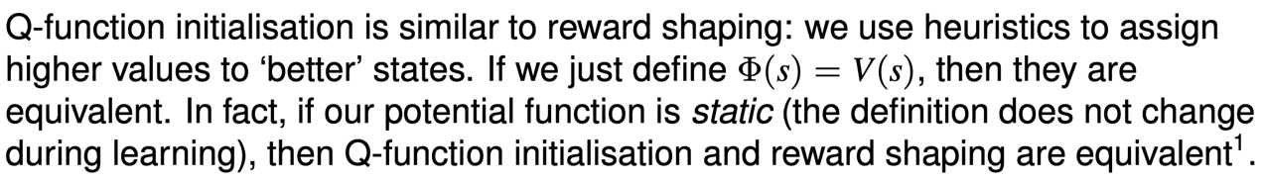

**TD(λ)**

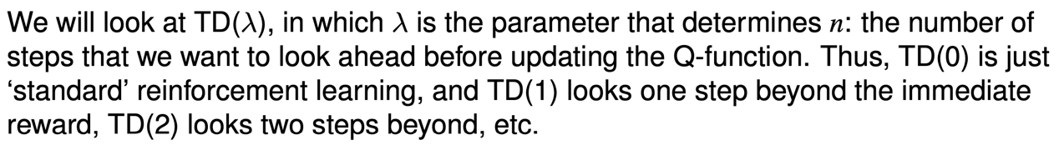

**Truncated Discounted Reward**:

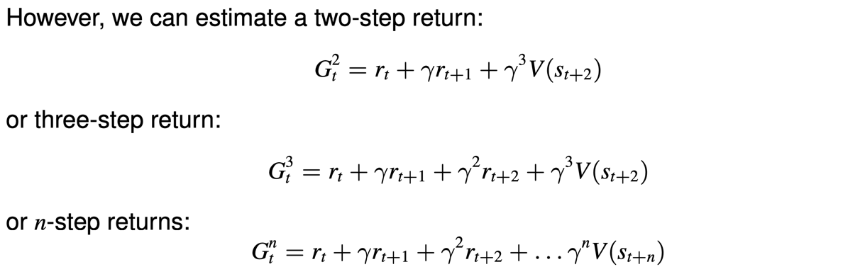



**Q-function Update for n-step RL**:

* Truncated discounted reward:



* Q-function update:



**n-step SARSA**:

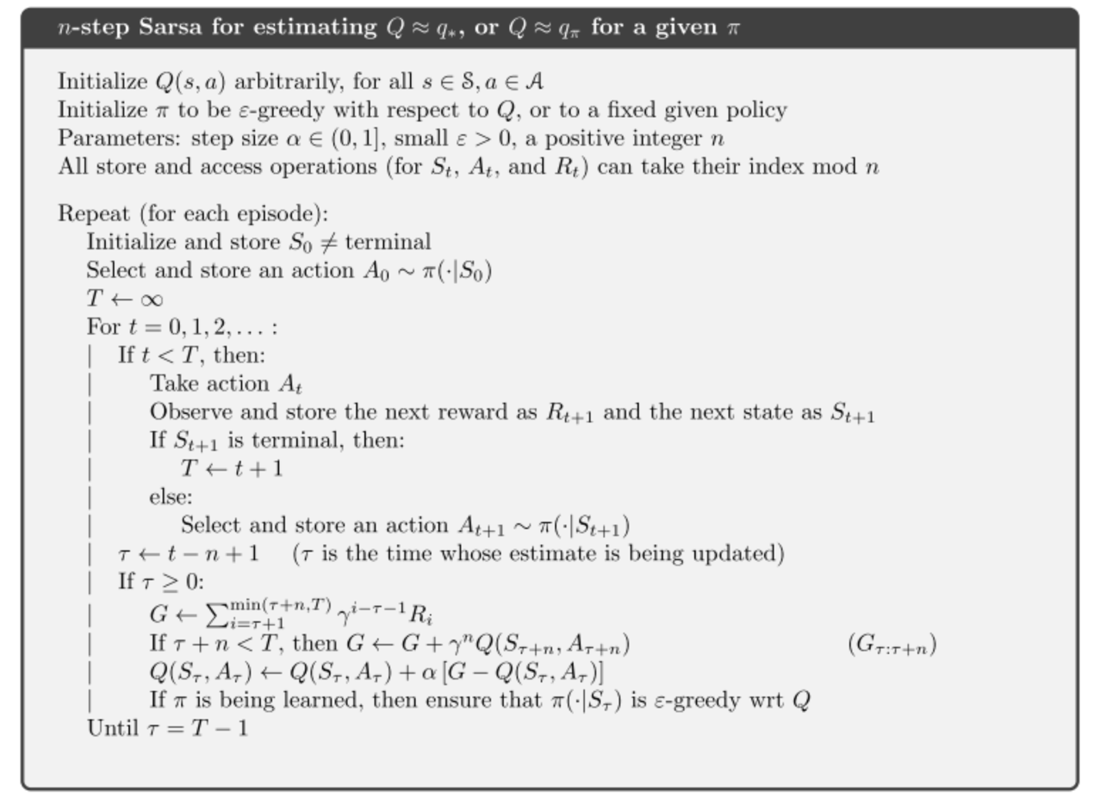

**Game Theory**:

* Normal form

What is Nash equilibrium; pure equilibrium vs mixed equilibrium; strongly dominant strategy vs weakly dominant strategy; expected payoff; indifference of mixed equilibrium.

* Extensive normal form

What is backward induction; Bayesian Game, e.g.

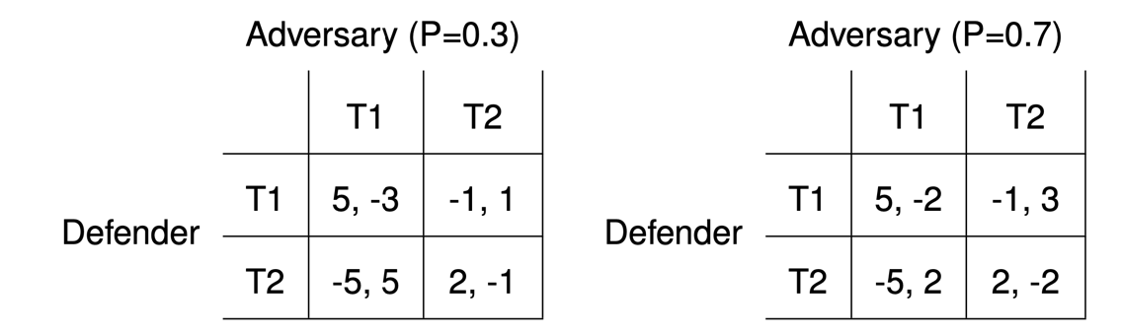

**Game Tree**:

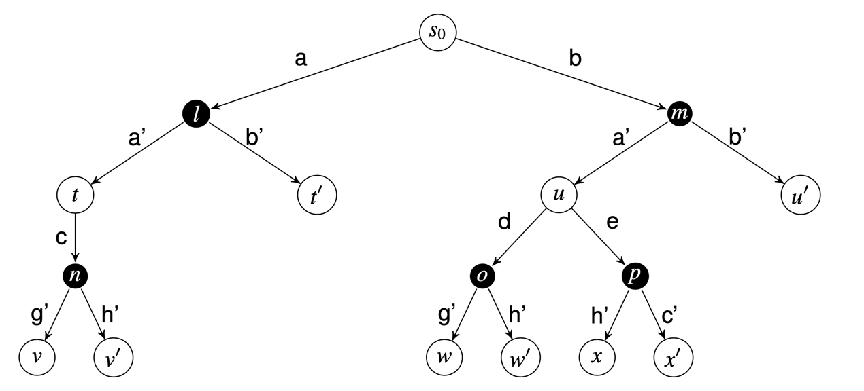

**MCTS for Games**:

* 4 Steps:

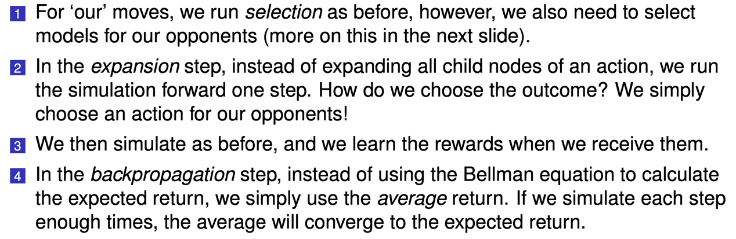

* Choose actions for opponents:

